CURRICULUM VITAE:
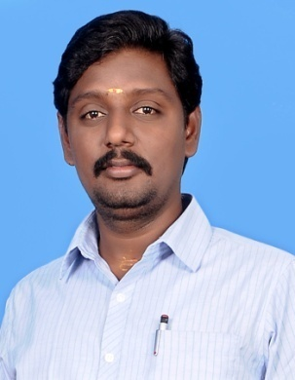
Objective:
Production management professional with 20 years of experience in large, fast-paced, mlti line facilities. Proven track record of achieving sustained improvements in quality cost and delivery functions.

- January 2018 TO Till date Free Lancer consultant ( Leather Products & Garments ,Process control , Quality Assurance & Quality control )
- Client
- CTC (Shoe makers France , Cleon ) , IQA ,YQS, VSC
- All Trends Pte Ltd.
- Jit Fashions Pte Ltd.

- October 2012 TO October 2017 Quality In charge (South India) CTC INDIA SERVICES PVT. LTD( Leather products & Garments ,Process control , Quality Assurance & Quality control )

- Job Profile :
- Implement and audit quality control processes.
- Maintain acceptable quality levels for all assigned products.
- Handled in-line, midline and finial inspection for leather shoes and Leather products.
- Final random inspection (AQL )
- Clients : LOUIS VUITTON ,MONOPRIX, ERAM,CASINO , LAREDOUDE , MOVITE , SYSTEME U,(COOPERATIVE U ) Etc

- MAY 2006 TO SEPTEMBER 2012- QUALITY CONTROLLER IN SHOETEK AGENCIES. ( FULL SHOES & UPPER)

- Job Profile :
- Implement and audit quality control processes.
- Maintain acceptable quality levels for shoes.
- Handled in-line, midline and finial inspection for leather shoes.
- 100 % Final Inspection
- Clients: STRARTRITE, HOTTER, CORAMI, DONAIRE and SATUR SAMA Ete..

- AUGUST 2003- APRIL 2006- WORKED AS A LINE SUPPERVISOR , LINE INCHARGE & QUALITY CONTROLLER IN GENERAL INDUSTRIAL LEATHER For ( SHOE UPPER )
.
- Job Profile :
- Line process setting
- Weekly production planning.
- Quality control
- Clients: Gabor.

- JUNE 2002 – JULY 2003- WORKED AS A QUALITY INCHARGE IN WISALL INTERNATIONAL ( SHOE UPPER)

- Job Profile :
- Implement and audit quality control processes.
- Handled in-line, midline and finial inspection for Shoe Upper.
- 100 % Final Inspection
- Clients: BALLEY.

- Core competencies :

- Quality Assurance
- Quality Control
- Production planning and organizing
- Problem identification and resolve
- Communication skills
- Team work
- Adaptability
- Conflict management
- Stress tolerance

- Qualifications :
- Educational - BBA.
- Technical - Footwear Technology
- Computer - MS office

- Personal information :

- Name - R RAJASEKARAN
- Address(s) - No : 3 RAMU STREET , SRINIVASAPURAM, GUDUVANCHERI, KANCHIPURAM – 603202
- Mobile(s) - + 91 95 66 084 948 & +91 9080824240
- E-mail - rajasekaranctc@gmail.com
- Nationality - INDIAN
- Date of birth - 03-03-1983
- Gender - MALE
- Language - ENGLISH & TAMIL

Regards,
R Rajasekaran

